Guideline

G1199
VTS Digital Communications

Edition 1.0
June 2026
urn:mrn:iala:pub:g1199:ed1.0

Revisions to this document are to be noted in the table prior to the issue of a revised document. The latest edition of the Guideline is the only version in force unless the Guideline is explicitly revoked by the Council.
Date | Revision details | Approval
June 2026 | Edition 1.0 | Council 04

1. INTRODUCTION 4
2. DOCUMENT PURPOSE 5
3. GENERAL PRINCIPLES OF VTS DIGITAL COMMUNICATIONS 5
3.1. MANAGING A MIX OF VOICE COMMUNICATION, DIGITAL COMMUNICATIONS, AND AUTOMATED DATA EXCHANGE 5
3.1.1. INFORMATION ORIGINATING FROM SOURCES OUTSIDE OF VTS 6
3.1.2. CYBER SECURITY 6
3.1.3. TECHNICAL FAILURES 6
3.1.4. HUMAN MACHINE INTERFACE (HMI) ASPECTS 6
3.2. DELIVERY OF THE INFORMATION 6
3.3. TECHNICAL INFRASTRUCTURE 7
4. VTS OPERATIONAL FUNCTIONS AND DIGITAL SERVICES 9
4.1. PUBLISHING INFORMATION ON VTS DIGITAL SERVICES 9
4.2. VTS SPECIFIC DIGITAL OPERATIONAL SERVICES 10
4.2.1. ROUTE FUNCTIONS 10
4.2.2. VTS INFORMATION FUNCTIONS 10
4.2.3. TRAFFIC FUNCTIONS 11
4.2.4. PLANNING FUNCTIONS 11
4.3. examples how to use operational functions 12
5. ABBREVIATIONS 14
6. REFERENCES 14

List of Figures
Figure 1 Illustration of different levels of services and functions in relation to the document context 4
Figure 2 Example of Communication Principle 7
Figure 3 High level view on the Digital Delivery of VTS Information 8
Figure 4 Detailed illustration of different levels of services in relation to the document context 9
Figure 5 Example of different services when vessel is arriving to port 12
Figure 6 Example of different services when vessel is arriving to anchorage area 13
Figure 7 Example of different services when vessel is transiting VTS area 13
Figure 8 Example of different services when vessel is departing from port 14

INTRODUCTION
Effective communication is an essential component for operations in the maritime domain and is achieved when the intended meaning of the sender and the perceived meaning of the receiver is the same.
In the context of Vessel Traffic Services (VTS), communication forms part of the broader concept of interaction between VTS and participating ships, as described in IMO Resolution A.1158(32) and further explained in Guideline G1089 Provision of a VTS. Digital communications represent one of the means by which this interaction can be achieved, alongside voice communications and automated data exchange.
If a vessel intends to use IMO Maritime Service MS-1 Vessel Traffic Service (IMO circular MSC.1/CIRC.1610/rev.1), it must be capable of receiving these and must subscribe to the digital services. The vessel is responsible for managing its subscriptions to and un-subscriptions from the digital services. Vessel Traffic Service (VTS) should ensure that VTS personnel are aware of which vessels have received information digitally, reducing the need for duplication via VHF. If a vessel has not received the information digitally, the VTS personnel are responsible for providing it via VHF voice communication in the conventional manner.
Modern technologies have improved communication through digital means. Compared to traditional voice communication, digital communication offers several advantages, including speed, efficiency, and reduced risk of misunderstandings. It can be used both with human involvement and in automated processes without human intervention.
Providing digital communication in a globally harmonized way requires a common understanding of the operational functions and standardised technical services.
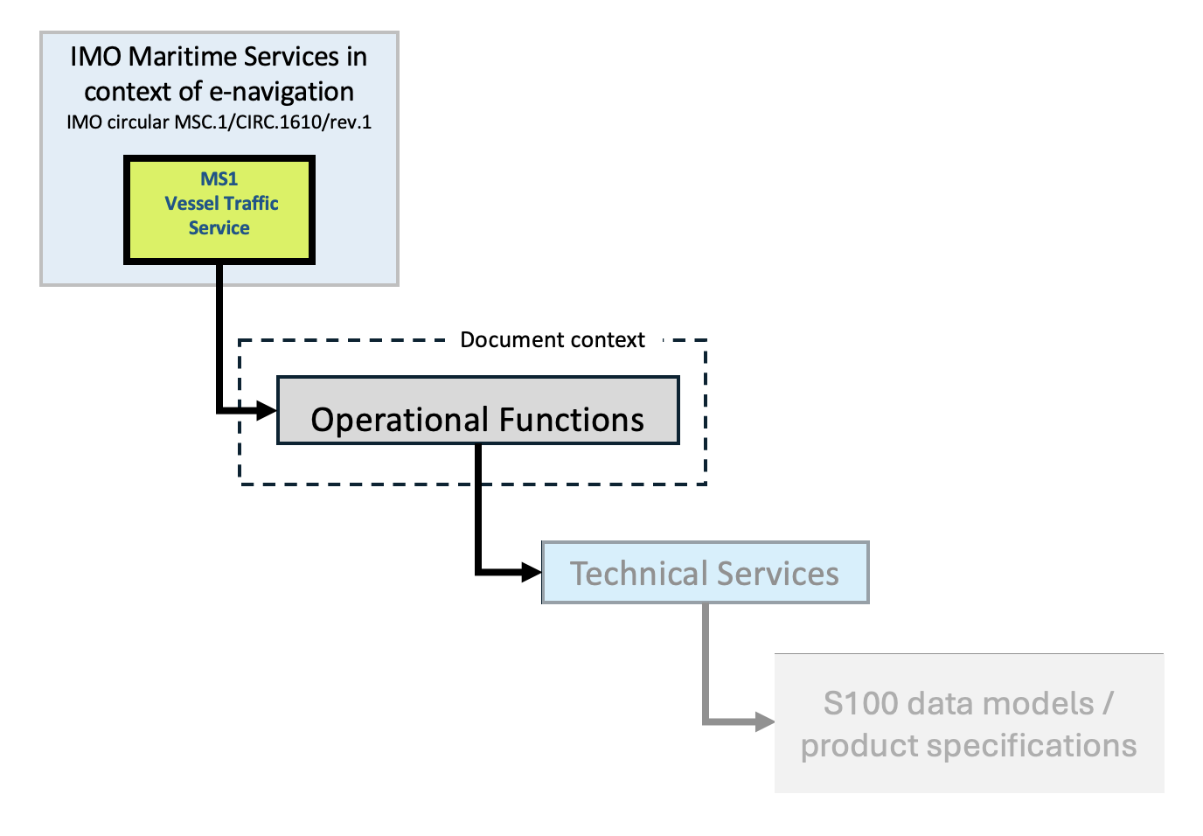
- Illustration of different levels of digital services and functions in relation to the document context

This guideline describes the operational procedures and functions which are specific to VTS as defined in Maritime Service 1 (MS 1) “Description of maritime services in the context of e-navigation (IMO circular MSC.1/CIRC.1610/rev.1). This guideline does not describe other Maritime Services which might be used by a VTS as they are under the responsibility of other international organizations acting as domain coordinating bodies for each Maritime Service.
In the following documents essential principles for the safe and efficient digital communication are mentioned and are used as a base for this Guideline:
- IMO Resolution A.1158(32) Guidelines for vessel traffic services states:
“Effective harmonized data exchange and information-sharing is fundamental to the overall operational efficiency and safety. VTS providers are encouraged to make use of automated reporting where possible.”
- IMO circular MSC.1/Circ.1595 e-navigation strategy implementation plan – update 1 states:
“As shipping moves into the digital world, e-navigation is expected to provide digital information and infrastructure for the benefit of maritime safety, security and protection of the marine environment, reducing the administrative burden and increasing the efficiency of maritime trade and transport.”
And that of the prioritised e-navigation solutions is:
“…improved communication of VTS Service Portfolio (not limited to VTS stations).”
- IMO circular MSC.1/CIRC.1610/rev.1 Descriptions of Maritime Services in the context of e-navigation defines the purpose of MS 1 Vessel Traffic Services (VTS) states:
“The purpose of this digital Maritime Service is to support the provision of VTS to participating ships by providing information in a digital format. Information could be presented in appropriate systems on board and ashore in order to create the means to reduce the administrative burden and information overload, reduce miscommunication due to external interference, simplify work procedures, promote sustainable shipping and increase navigational safety.”

DOCUMENT PURPOSE
The guideline defines functions and services for digital communication from a VTS operational perspective and aims to harmonize VTS digital communications through standard procedures and technical services. The technical services for exchanging digital information between vessels and VTS are under development. The operational requirements set out in this document should therefore give guidance on further development.
In addition to this Guideline, there is a document on the IALA website under the “Topical Matters”, which provides useful operational elaborated use cases of VTS Digital Communications. The document “Use Cases for VTS Digital Communications” is a living resource, updated as digitalisation advances and new technologies emerge, supporting the continuous improvement of VTS operational procedures.
This Guideline is associated with Recommendation R1012 VTS Communications, a normative provision of Standard S1040 Vessel Traffic Services (VTS). To demonstrate compliance with the Recommendation, the provisions of this Guideline should be taken into account.

GENERAL PRINCIPLES OF VTS DIGITAL COMMUNICATIONS

MANAGING A MIX OF VOICE COMMUNICATION, DIGITAL COMMUNICATIONS, AND AUTOMATED DATA EXCHANGE
The digitalisation of information will diversify the communication means between shore and vessels and will affect VTS procedures regarding exchange of information. VTS interaction with vessels has traditionally almost exclusively been via VHF voice communications. It is expected that VHF voice communication will be partially replaced by digital communication in the future. The mix of voice communication, digital communication, and automated data exchange may differ from VTS to VTS.
VTS has to manage the mix of voice communication, digital communication, and automated data exchange. The use of digital communication could reduce workload by automating repetitive tasks, which could lead to reduction of the VHF traffic, communication barriers and the risk of misunderstandings. Digital communications also have the opportunity to disseminate information as well as consolidate and process the information for better decision support.
Messages can be conveyed to an individual vessel or a group of vessels. This not only includes person-to-person but also person-to-machine, machine-to-machine and machine-to-person communication. The change of communication and interaction to digital can also utilise automated processes in many situations.
The introduction of digital communication marks a period where digital communication and voice communication exists next to each other. The gradual advent of technical services may potential increase VTS workload, as the same tasks must be executed using both the new and old methods side by side. Over time digital communication holds the potential to reduce workload by automating repetitive tasks and voice communication.
Voice communications can be also used in addition to digital communications for example for urgent and time critical messages and can act as a backup for digital communication service technical failure.

INFORMATION ORIGINATING FROM SOURCES OUTSIDE OF VTS
When transitioning to digital communications some of the information provided to vessels today by VTS may be provided directly to vessels from other sources. This can include for example hydrographic and environmental information, information on Marine Aids to Navigation (AtoN) and Maritime Safety Information (MSI).

CYBER SECURITY
From the VTS point of view the digital data exchange is secure unless the system indicates the data quality is insufficient due to reduced cyber security level. In these cases, the VTS personnel should revert to voice communication and the conventional way of working. For cases in which cyber security is impaired and not system detectable, VTS personnel should receive training how such cases might be observed and detected.

TECHNICAL FAILURES
In case the digital communication service suffers a technical failure, it is a responsibility of a VTS to have alternative procedure in place. One option is to revert to the conventional way of working with voice communication. It is possible that the VTS operators will not be able to revert to the conventional way of working serving the amount of traffic at hand. The other possible option is to have a redundant digital communication system or a back-up system.

HUMAN MACHINE INTERFACE (HMI) ASPECTS
Digital communication has the potential to streamline the VTS operations for a VTS center. It depends however highly on the specific implementation in the VTS system to which level an individual VTS operator is supported in his or her task. From a system architecture perspective and system acquisition perspective it might seem a logical solution to have digital communication functionality added as a separate function on the VTS operator working position. The real benefit of digital communication however will only be achieved with an HMI solution which supports the task of the operator optimally with an integrated HMI solution. Especially for VTS centers where the workload of the VTS operators forms a bottleneck in the operation, the HMI design is vital to assure the workload reduces when applying digital communication rather than increases.

DELIVERY OF THE INFORMATION
The added benefit of digital communication is having the information in standardized structure, ensuring that the same information is available to all relevant actors when required and designed in a way to minimize misinterpretations and to provide common situational awareness. This includes machine-to-machine communications between VTS, vessels and other relevant actors.
Digital communications should have the same communication procedures as the voice communications where applicable. Digital communication should be processed according to G1132 VTS Voice Communications and Phraseology where applicable.
To achieve closed-loop communication in digital communications different types of responses should be implemented such as:
- Delivered: system acknowledges message delivery
- Received: human or system acknowledges message reception
- Approved: human or system approves the content of the message
In Figure 2 typical communication sequence is presented by means of a time sequence diagram explaining the sequence of message exchanges between VTS and vessels. Time progresses from left to right in the figure. In this example, it shows the arrival of a vessel through a VTS area towards a berth. VTS represents the top line and the vessel the bottom line in the figure. The arrows depict the messages being transferred between VTS and vessels as time progresses. In the document “Use Cases for VTS Digital Communications”, on the IALA website, the specific message exchange is explained by such time sequence diagrams for the specific functions and services. 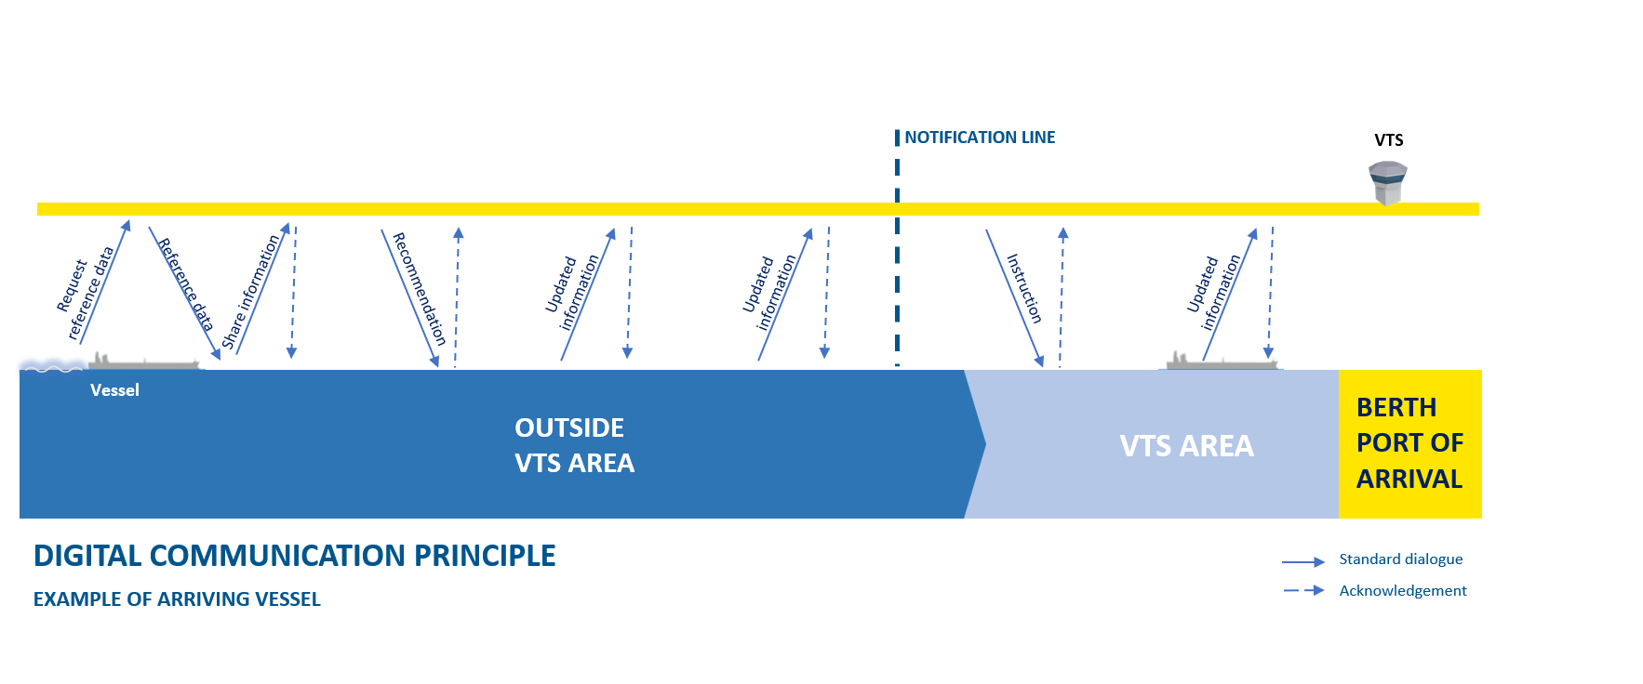
- Example of Digital Communication Principle

TECHNICAL INFRASTRUCTURE
Digital communications require technical solutions that are different and more complex than technical infrastructure needed for traditional communication methods like VHF voice. Technical infrastructure for digital communications consists of various technical building blocks but also immaterial assets like specifications, data models and harmonized ways to manage technical services and underlying platforms. Figure 3 shows a simplified view of technical services related to VTS digital communications.
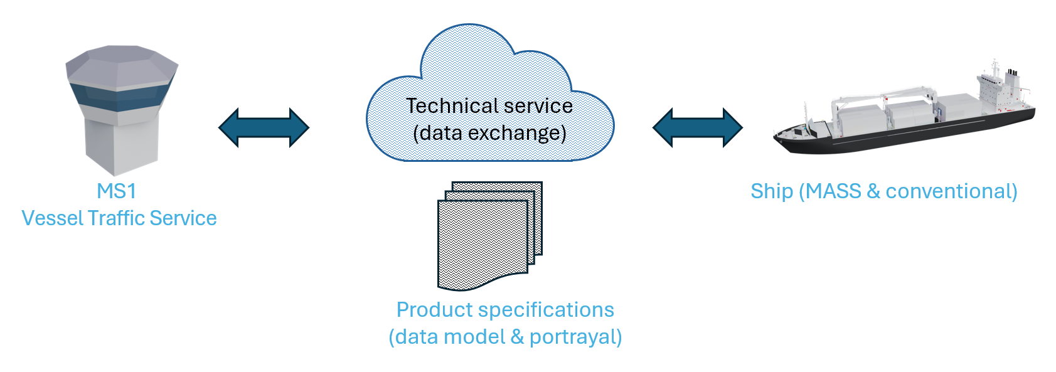
- High level view on the Digital Delivery of VTS Information
The digital communication for VTS should reach beyond one single VTS area or be ideally even globally accessible. The technical services that implement digital communications for VTS should be standardised, secure and robust as described in section 4.1. All these can be achieved by establishing technical infrastructure according to Service Oriented Architecture (SOA) principles. The implementation of VTS digital communications requires at least following building blocks:
- Harmonized way to describe technical services and link them to relevant data models according to IMO resolution MSC.467(101) “Guidance on the definition and harmonization of the format and structure of maritime services in the context of e-navigation”;
- Unified and global data models that are compliant with IMO’s Common Maritime Data Structure (CMDS);
- Global and unique identifiers for data and maritime resource for this data, such as MRNs;
- Service platform supporting maritime SOA architecture and service provision; and
- Data exchange infrastructure to facilitate the real-time and cyber secure data exchange using standardised data transport mechanisms;
IALA and other maritime organisations have developed extensive guidance to support implementation of these requirements in a harmonized way. The most relevant guidelines and standards for the building blocks mentioned above are as follows:
- Guideline G1128 The Specification of e-Navigation Technical Services
- IHO S-100 Universal Hydrographic Data Model and Guidelines G1088 Introduction to Preparing S-100 Product Specifications and G1106 Producing an IALA S100 Product Specification
- Guideline G1143 Unique Identifiers for Maritime Resources
- Guidelines G1157 Web Service Based S-100 Data Exchange and G1161 Evaluation of Platforms for the Provision of Maritime Services in the Context of e-Navigation
- The data exchange itself can be implemented using various industrial standards. The most relevant in the context of VTS digital communications are SECOM (IEC 63173-2), MMS (RTCM standard 13900.0 for Maritime Messaging Service Architecture and Protocol) and VDES VDE (Recommendation R1007 The VHF Data Exchange System (VDES) For Shore Infrastructure)

VTS OPERATIONAL FUNCTIONS AND DIGITAL SERVICES
This paragraph includes the operational descriptions for potential digital services identified in the domain of Maritime Services in the context of e-Navigation. The operational functions/services are not limited, if needed further functions/services can be added. A local implementation of a function may include all, or subset of, underlying services. Before implementation of digital services, a risk assessment should be carried out.
The Maritime Service for VTS includes several different potential operational functions associated with this Maritime Service. These operational functions can be divided into VTS-specific services and services developed within other Maritime Services. This guideline only focuses on the VTS specific operational functions under the remit of IALA, MS 1 VTS. Development of technical services is out of scope of this guideline. Operational functions are divided in services (Figure 4). These digital services are worked out in use cases that can be found under the headline “VTS Digital Communication” on the IALA website of “Topical Matters”.
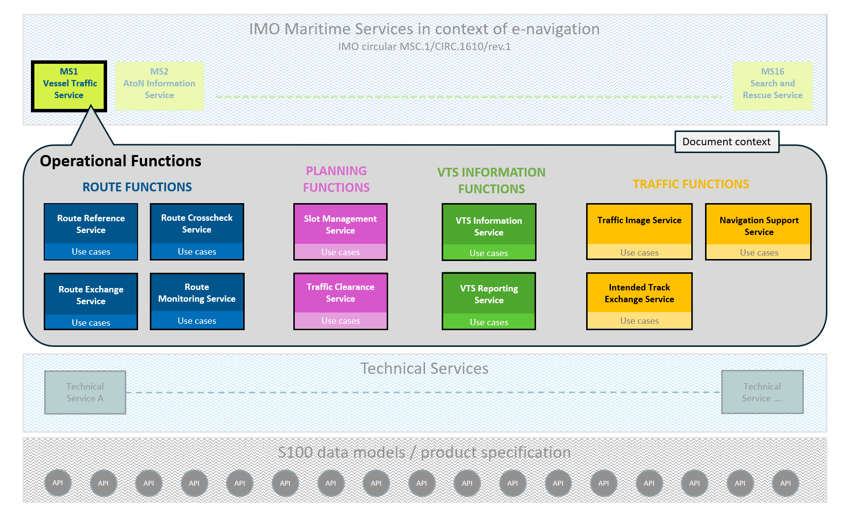
- Detailed illustration of different levels of digital services in relation to the document context
Technical services are needed to coordinate a seamless combination between different product specifications. Information provided using S-100 based product specifications is brought together by technical services to deliver a Maritime Service. G1128 gives guidance on how to make specifications of Technical Services. A Maritime Service can be implemented by one or more Technical Services and one technical service can implement multiple operational functions.

PUBLISHING INFORMATION ON VTS DIGITAL SERVICES
The number and type of digital services may vary between different VTS centres. Mariners should have access to information about which digital services are available at each VTS. Additionally, VTS digital services should be compatible with and supported by on-board systems.

VTS SPECIFIC DIGITAL OPERATIONAL SERVICES
VTS specific digital operational services provide structured methods for exchanging data between vessels and VTS. VTS specific operational functions and digital services are described in this section. The principles for information exchange are provided in Section 4.2 of this Guideline.
Currently identified VTS specific Operational functions are:
- Route Functions
- VTS Information Functions
- Traffic Functions
- Planning Functions

ROUTE FUNCTIONS
Route Functions consist of digital services that enable the exchange of routes, the provision of reference routes, the crosschecking of planned routes in relation to conditions in the VTS area, and the monitoring of vessel movements in accordance to their planned routes. These digital services provide a structured way for vessels and VTS to share, verify, and oversee navigational information to support safe and efficient maritime traffic in the VTS area.

DIGITAL ROUTE EXCHANGE SERVICE
Digital Route Exchange Service enables vessels and VTS to share planned routes and schedules in a standardized format. By exchanging route information digitally, vessel and VTS share a common understanding of navigational intentions, supporting safe and efficient vessel traffic, while also reducing VHF communication load within the VTS area. Furthermore, Digital Route Exchange Service is the base for other digital route-related services such as Digital Route Monitoring, Digital Route Crosscheck, and Digital Route Reference.

DIGITAL ROUTE REFERENCE SERVICE
With Digital Route Reference Service VTS and other service providers offer routes and waypoints in electronic format, Digital Route Reference Service is designed to assist mariners in their voyage planning to define the suitable route on commonly used passages, such as shipping lanes, approaches to ports, and coastal routes. Digital Reference routes can be fully predefined and/or can be calculated based on predefined waypoints.

DIGITAL ROUTE CROSSCHECK SERVICE
The purpose of Digital Route Crosscheck Service is to validate a planned or monitored route from the vessel and compare the information with expertise of the VTS and its information regarding the specific VTS area, e.g. traffic separation, depth, speed restriction, etc. When the VTS receives a route from a vessel, the VTS should be able to execute a Route cross check. The cross-checking may be done before the vessel’s departure or before arrival at a a VTS area. The cross-check may include Under Keel Clearance (UKC), air draft, no violation of no-go areas, Maritime Safety Information and compliance with mandatory routeing.

DIGITAL ROUTE MONITORING SERVICE
The Route Monitoring Service is used to monitor vessels´ movement in vicinity and in the VTS area. Within this service the VTS may detect vessels’ deviating from their routes or schedules, allowing the VTS to intervene promptly in case of potential safety hazards and navigational issues.

VTS INFORMATION FUNCTIONS
VTS Information Functions include digital services that enable the exchange of information between vessels and the VTS. Digital services contain the reporting and the provision of structured and unstructured navigational and traffic-related information. These functions ensure that accurate, timely, and relevant information is shared to enhance situational awareness, support safe and efficient navigation.

DIGITAL VTS REPORTING SERVICE
Digital VTS Reporting service is designed for vessels to digitally report information to the VTS as specified by the VTS. This includes an arrival/departure report, position report and specific information about the vessel which may affect the traffic in the VTS area.

DIGITAL VTS INFORMATION SERVICE
The primary purpose of the Digital VTS Information Service is to support the safe navigation of vessels within and in the vicinity of the VTS area by providing relevant information. This may include details on uncharted obstacles, traffic conditions, pilotage, UKC or general operations. The service can deliver both structured and unstructured information, where digital messages also should begin with a message marker.

TRAFFIC FUNCTIONS
Traffic Functions consist of digital services that enable the exchange and sharing of real-time digital traffic information between vessels and VTS. Digital services include the provision of a common traffic image, the exchange of intended tracks, and digital navigation support. Together, these digital services enhance situational awareness, reduce the risk of collisions, and allow timely communication of information to ensure safe and efficient vessel movements within the VTS area. Digital services ensure that vessels and VTS have a common understanding of the traffic situation, enabling timely decisions and actions to maintain navigational safety.

DIGITAL TRAFFIC IMAGE SERVICE
Digital Traffic Image Service enables the exchange of real-time digital traffic information between VTS and vessels. For example, using sources like AIS, radar, or CCTV, it provides vessels and VTS with an up-to-date traffic picture and supports the creation of a common traffic image within the VTS area.

DIGITAL INTENDED TRACK EXCHANGE SERVICE
Digital intended track exchange service is designed to automatically broadcast the intended trajectory of the vessel covering a route segment of a certain amount of time which is significantly shorter, rather minutes than hours, than the complete planned route. This intended trajectory may consist of the current track and speed or a limited set of waypoints of the route including time at each waypoint. Depending on the applied control of the vessel, for example manual control, autopilot or track pilot, it broadcasts the track and speed or a set of waypoints. Vessels share their intentions from vessel to vessel as well as from vessel to VTS digitally. This allows vessels to avoid potential conflicts because this digital service provides the vessels insight in the developing traffic situation. With this digital service, the VTS may receive all vessels’ intentions within the VTS area, allowing the VTS to intervene promptly in case of potential safety hazards and navigational issues.

DIGITAL NAVIGATION SUPPORT SERVICE
Digital Navigation Support Service supports VTS in responding to developing unsafe situations. These situations may include a vessel unsure of its position, deviating from its route, needing guidance to anchorage, experiencing equipment failure, facing severe weather, being at risk of grounding or collision, or requiring emergency support. The digital service provides navigational information, advice, warnings or instructions to individual vessels or to groups of vessels within the VTS area. All messages are transmitted reliably to ensure that vessels receive them and can maintain safe navigation.

PLANNING FUNCTIONS
Planning Functions consist of digital services that support the safe and efficient planning of vessel movements within a VTS area. Digital services include providing traffic clearance to ensure safe passage and allocating time slots for arrivals, departures, or transits. These digital services allow VTS to coordinate traffic flow, prevent congestions and/or conflicts, and optimise the safe and efficient use of the VTS area.

DIGITAL TRAFFIC CLEARANCE SERVICE
Digital Traffic Clearance refers to the process of ensuring that there is sufficient space and time for vessels to navigate safely through an area, taking into account other vessels, obstructions, regulatory and environmental factors. The Digital Traffic Clearance Service provides vessels with permission to proceed, set conditions and/or denies clearance. Within this digital service the VTS coordinates, authorizes, and monitors the approach and passage of vessels through the area.

DIGITAL SLOT MANAGEMENT SERVICE
Digital Slot Management Service is designed to provide time slots for vessels in advance to ensure safe, efficient, and organized movement within the VTS area. A time slot includes scheduling and allocation for vessels within a VTS-area. The digital service includes assigning specific time slots for vessels' arrival, departure, or transit. The time slot may be based on for example weather and/or hydrologic conditions (e.g. tide, fog), UKC, port/area resources (e.g. berth, anchorage), traffic density, infrastructure (e.g. bridge, lock), type/size of vessel. This integrated approach enables the VTS to manage traffic flow while maintaining safety and operational efficiency.

examples how to use operational functions
Figure 5 to 8 show four examples of the applicability of the various operational functions of digital communication. At the bottom of the figure the vessel voyage is indicated where the voyage progresses from left to right. The dark blue at the bottom stands for the vessel sailing outside the VTS area, the light blue stands for the VTS area with or without an anchoring area and the yellow part is the port of arrival or departure. The different colored bars above indicate in which phase of the voyage the various services of the four functions can become relevant and can be applied.
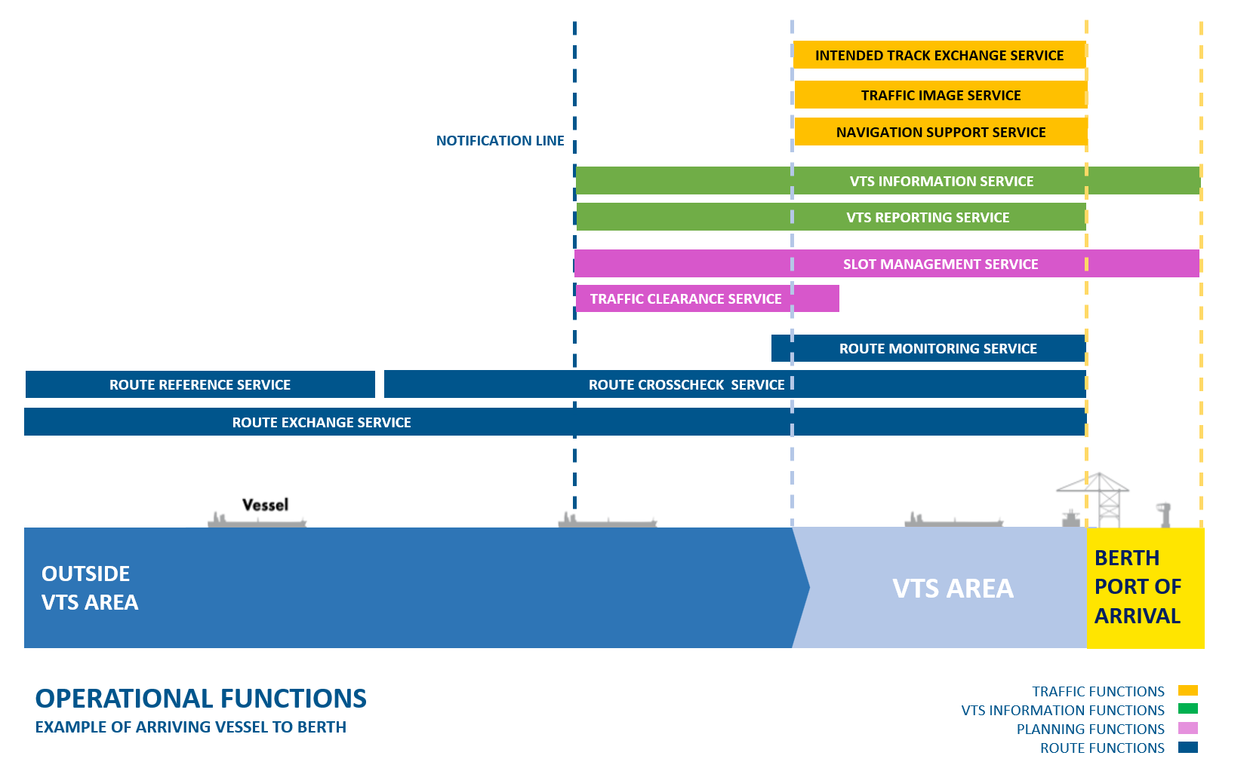
- Example of different digital services when a vessel is arriving to a port within a VTS area

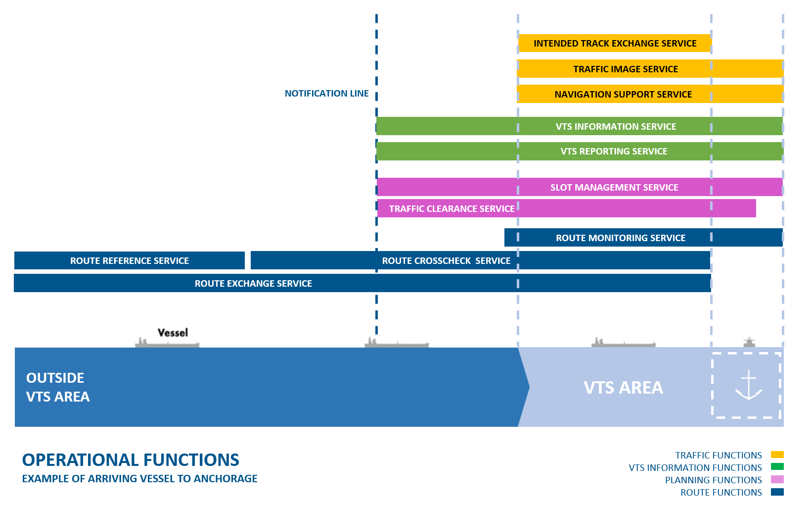
- F Example of different digital services when a vessel is arriving to an anchorage area within a VTS area
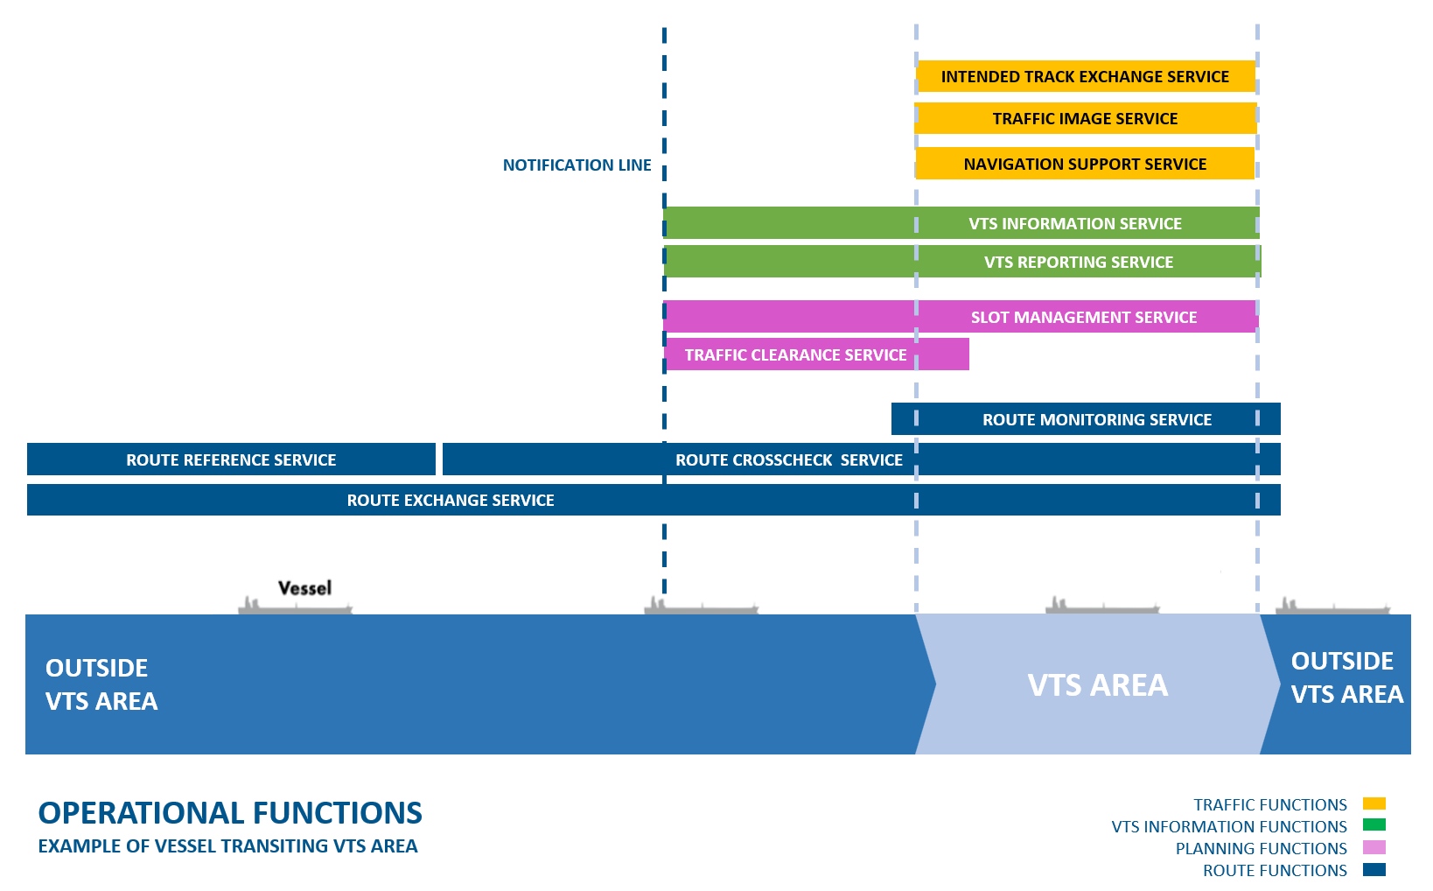
- Example of different digital services when a vessel is transiting a VTS area

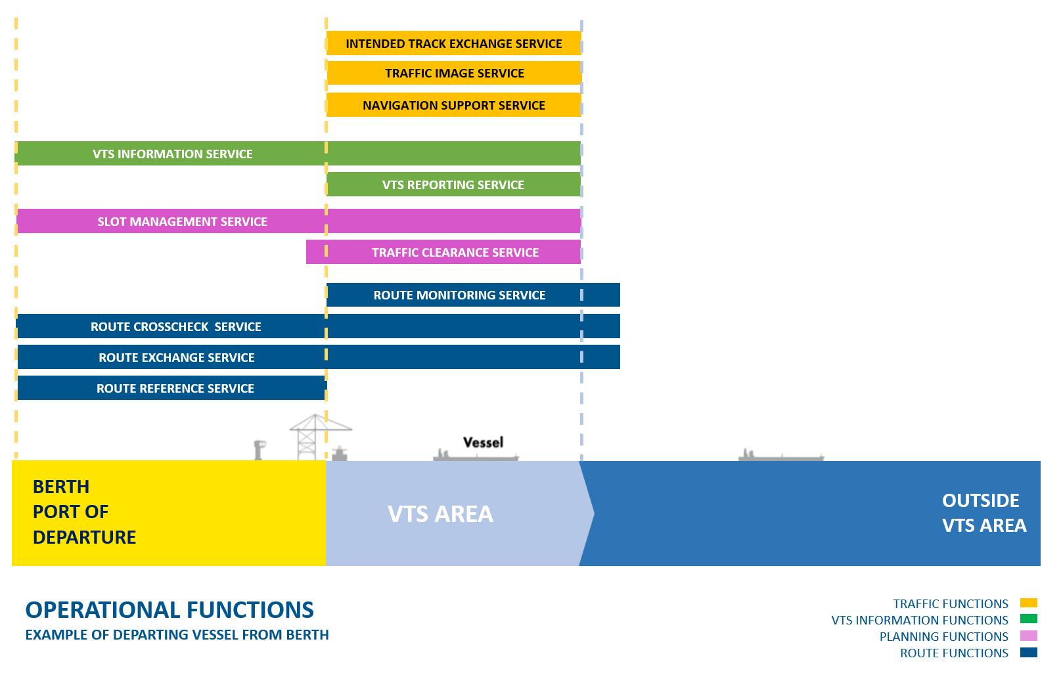
- Example of different digital services when a vessel is departing from a port within a VTS area

ABBREVIATIONS
AIS Automatic Identification System
CCTV Closed-Circuit Television
CMDS Common Maritime Data Structure
IMO International Maritime Organisation
HMI Human Machine Interface
JIT Just in Time arrival
MASS Maritime Autonomous Surface Ship
MRN Marine Resource Name
MS Maritime Service in the context of e-navigation
MSC IMO Maritime Safety Committee
MSI Maritime Safety Information
SOA Service Oriented Architecture
VHF Very High Frequency
VTS Vessel Traffic Services
VTSO VTS Operator

REFERENCES
- IMO MSC.1/Circ.1610/Rev.1 Descriptions of Maritime Services in the Context of E-Navigation
- IMO Resolution A.1158(32) Guidelines for vessel traffic services
- IMO Circular MSC.1/Circ.1595 E-navigation strategy implementation plan – update 1
- IALA Guideline G1182 Cyber Security Specifics from an IALA Perspective
- IALA Guideline G1132 VTS Voice Communication and Phraseology
- IMO Resolution MSC.467(101) Guidance on the definition and harmonization of the format and structure of maritime services in the context of e-navigation
- IALA Guideline G1128 The Specification of e-Navigation Technical Services
- IHO S-100 Universal Hydrographic Data Model
- IALA Guideline G1143 Unique Identifiers for Maritime Resources
- IALA Guideline G1157 Web Service Based S-100 Data Exchange
- IALA Guideline G1161 Evaluation of Platforms for the Provision of Maritime Services in the Context of e-Navigation
- IALA Guideline G1088 Introduction to Preparing S-100 Product Specifications
- IALA Guideline G1106 Producing an IALA S100 Product Specification
- IALA Guideline G1089 Provision of a VTS

